MECHANICAL DESIGN MANUAL SUMMARY SHEET

SUBJECT: Piping

DESCRIPTION: Natural Gas Piping and Propane Fuel Gas Systems

SPEC SECTION: 15410

APPLICABLE
REFERENCES: ASPE Data Book Chapter 6 - Fuel Gas Piping
BOCA Mechanical Code
Local Utility Gas Rules and Regulations
International Fuel Gas Code
NFPA #54 National Fuel Gas Code
NFPA 58 - Liquefied Petroleum Gas Code
State and Local Codes
Uniform Plumbing Code

DATE: August 26, 1991

PREPARED BY: Michael J. Taube and Brian Winterle, P.E.

NATURAL GAS PIPING

Design guide

- ALL REQUIREMENTS MUST BE VERIFIED WITH LOCAL AUTHORITY HAVING JURISDICTION.
- Outside of buildings, gas mains run at higher pressures, typically about 1 to 50 PSI (closer to 5 PSI).
- Utility companies normally supply natural gas at 7”, 2 PSIG, 5 PSIG, or 10 PSIG. This is typical for most gas companies (verify with local utility). The gas line from the utility will be run underground to the building and then needs to break grade before going into the building. This allows for ventilation of the gas to the atmosphere. Most gas meters and regulators are located outside and are supplied by the utility company. Verify requirements for location next to building opening.
- Some applications will require different pieces of equipment, which require different gas pressures. The utility will only supply one gas regulator. The Owner will have to provide any other regulators. If this is the case, the utility company should supply at a higher pressure.
- Gas pressure regulators should have the inlet pressure, outlet pressure, and flow rate specified.
- Some gas companies will not allow lines greater than 2 PSI through a building. NPFA 54 limits indoor pressure to 5 PSIG.
- Gas piping is usually schedule 40 black steel. If underground, it is coated black steel or polyethylene with a metallic identifier wire. Larger steel pipe will be welded; smaller piping will have screwed fittings (verify with code official).
- If pressure is greater than 5 PSIG, pipe must be welded, regardless of size per NFPA 54.
- Copper piping is not used. It is not allowed by code due to the chemical reaction with sulfur in natural gas.
- Install a manual shutoff valve and dirt leg ahead of each piece of gas-burning equipment.
- Gas lines may be prohibited in concealed spaces, such as clothes chute, chimney or gas vent, dumbwaiter or elevator shafts.
- Gas lines can be run through sheetrock and studs only if vents are supplied for air circulation.
- Gas lines cannot be run through ducts.
- If you have to run under a floor slab, use a sleeve that is open to a ventilated space or a vented trench system.
- Gas piping can be routed inside tunnels if they are ventilated.
- Valves shall not be located in accessible spaces between a fixed ceiling/structures and dropped ceiling unless properly vented. Refer to NFPA 54 for requirements.

design check list
- Verify gas pressure requirements for all equipment.
- Verify gas pressure supplied by utility company. You will need the total gas load for the building and location for gas service to enter the building.
- Is a concrete pad or bollards required for gas meter? Check with utility company.
- Any regulators installed inside the building? Vent to outside individually. Designer should provide manufacturer’s representative with the gas pressure and load of each device when a regulator is required. Sizing of regulator and vent shall be by manufacturer’s representative, not KJWW Engineering.
- Draw a sketch of all gas equipment located inside building. Note piping lengths and equipment loads for each. File in design file for future reference.
- Provide combustion air for any indoor gas burning equipment. Examples: Boilers, hot water heaters, furnace.
- Make sure vent for exterior rooftop gas regulators is above snow level so vent does not ice up.
- Some equipment may be supplied with a factory mounted pressure regulator.

Number Values - Relationship between PSI & Inches Water Column:

1 PSI = 2.31 ft (1 PSI x 144 sq. in. divided by 62.4 lbs. per ft.) = 27.72 inches water column

Gas Pressure (PSI) | Equivalent Inches W.C.
0.25 | 6.8 (industry standard 7” W.C.)
0.5 | 13.6 (industry standard 14” W.C.)
1.0 | 27.72
2.0 | 55.44
5.0 | 138.6
10.0 | 277.2
20.0 | 554.4

1 CFH = approximately 1000 BTU/hr (typically 1 CFH = 1052 BTU/hr, depending on the quality of the gas) (gas loads will typically be given in BTU/hr and gas tables are in CFH).

Basic Requirements:
- Most small equipment is designed to operate at 7” W.C. gas pressure or less. Larger equipment, such as boilers, make-up air units, and industrial equipment, often require higher pressure. Verify gas pressure requirements of all equipment with manufacturer.
- Some boilers will be called low pressure, but actually require 8” to 9” of pressure. When higher pressures are required, the service from the utility company should be based on 2 PSIG or 5 PSIG per NFPA 54. Regulators will then be required at all fuel burning devices to reduce the pressure and allow proper operation. Note: NFPA 54 has an exception for boiler rooms and for welded pipe.

Natural Gas Pipe Sizing:
- The most important thing to remember in sizing gas piping is that the pressure drop is calculated over the entire pipe length and not per 100’. Gas pipe must be sized on a set pressure at the outlet of the meter or regulator, and a set pressure at the inlet to the gas burner. Therefore, as the pipe length gets longer, the pipe must get larger to obtain the same flow.
- Code requires low pressure gas piping to be sized for a pressure drop of 0.3” water column. High pressure piping is sized for a maximum pressure drop of 10% of the delivery pressure.
- Typically, pipe sizing tables are based on equivalent length. This is the actual length of the pipe plus an allowance for all fittings and valves. (Table C.3) gives equivalent lengths for many fittings.
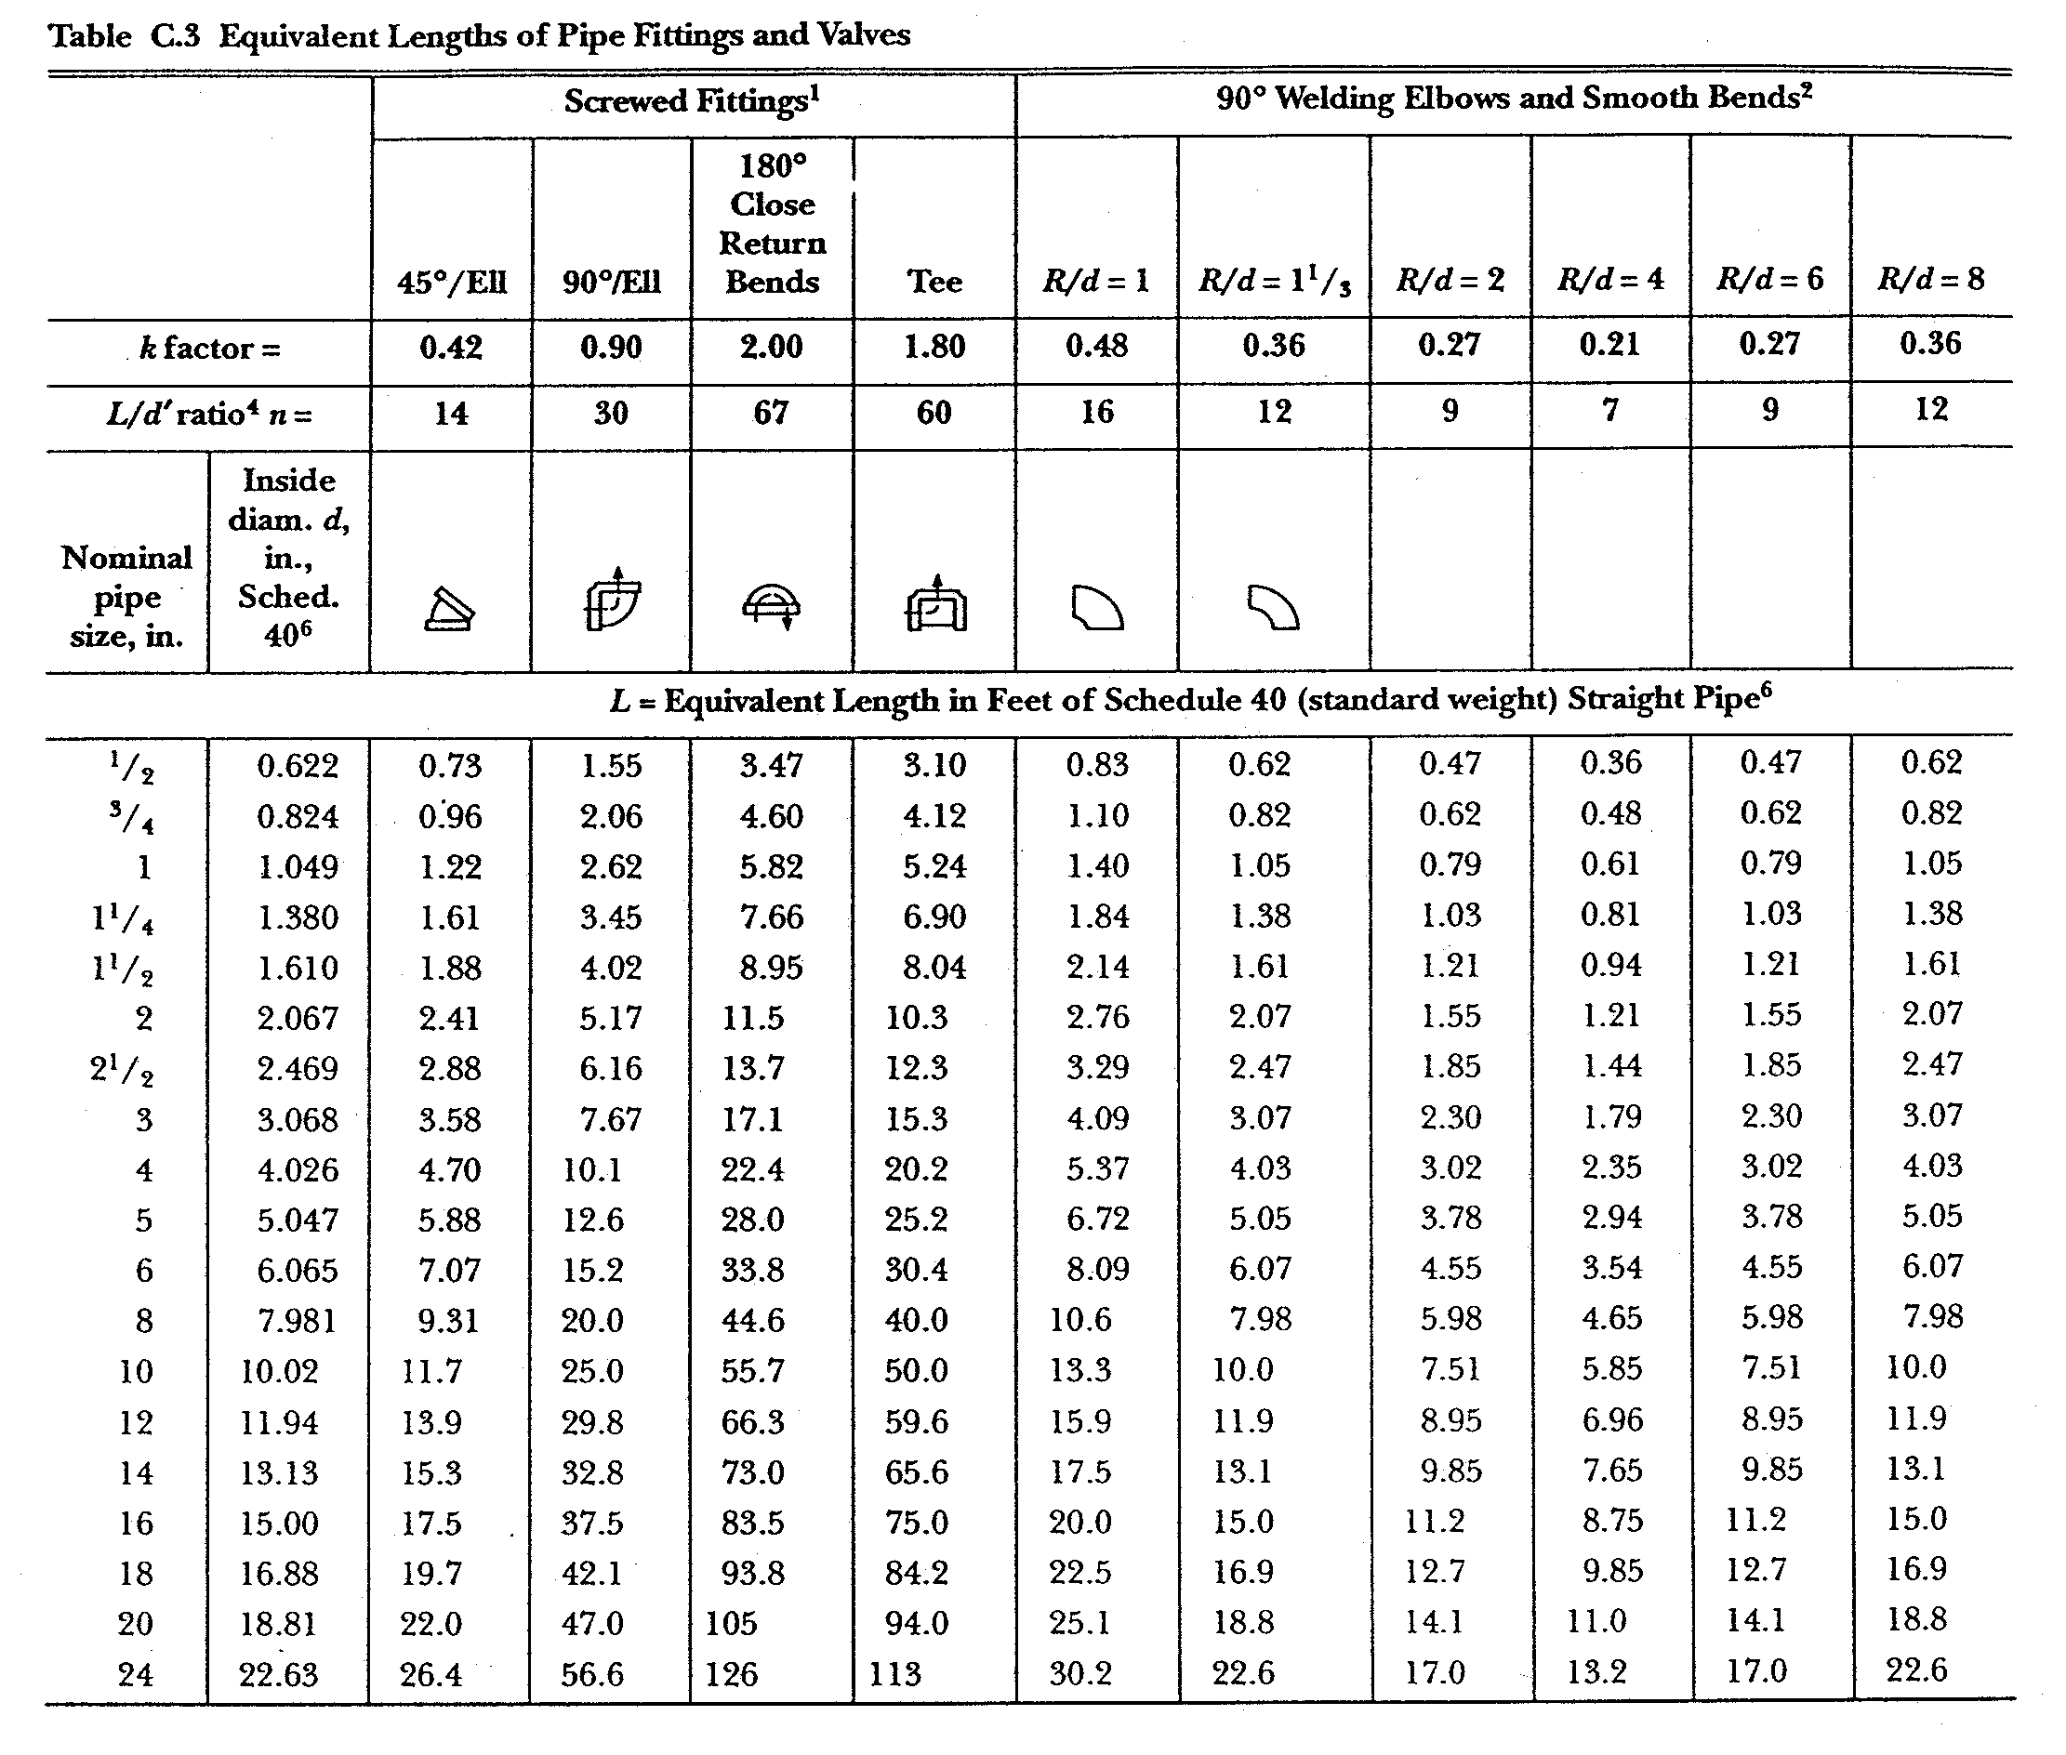
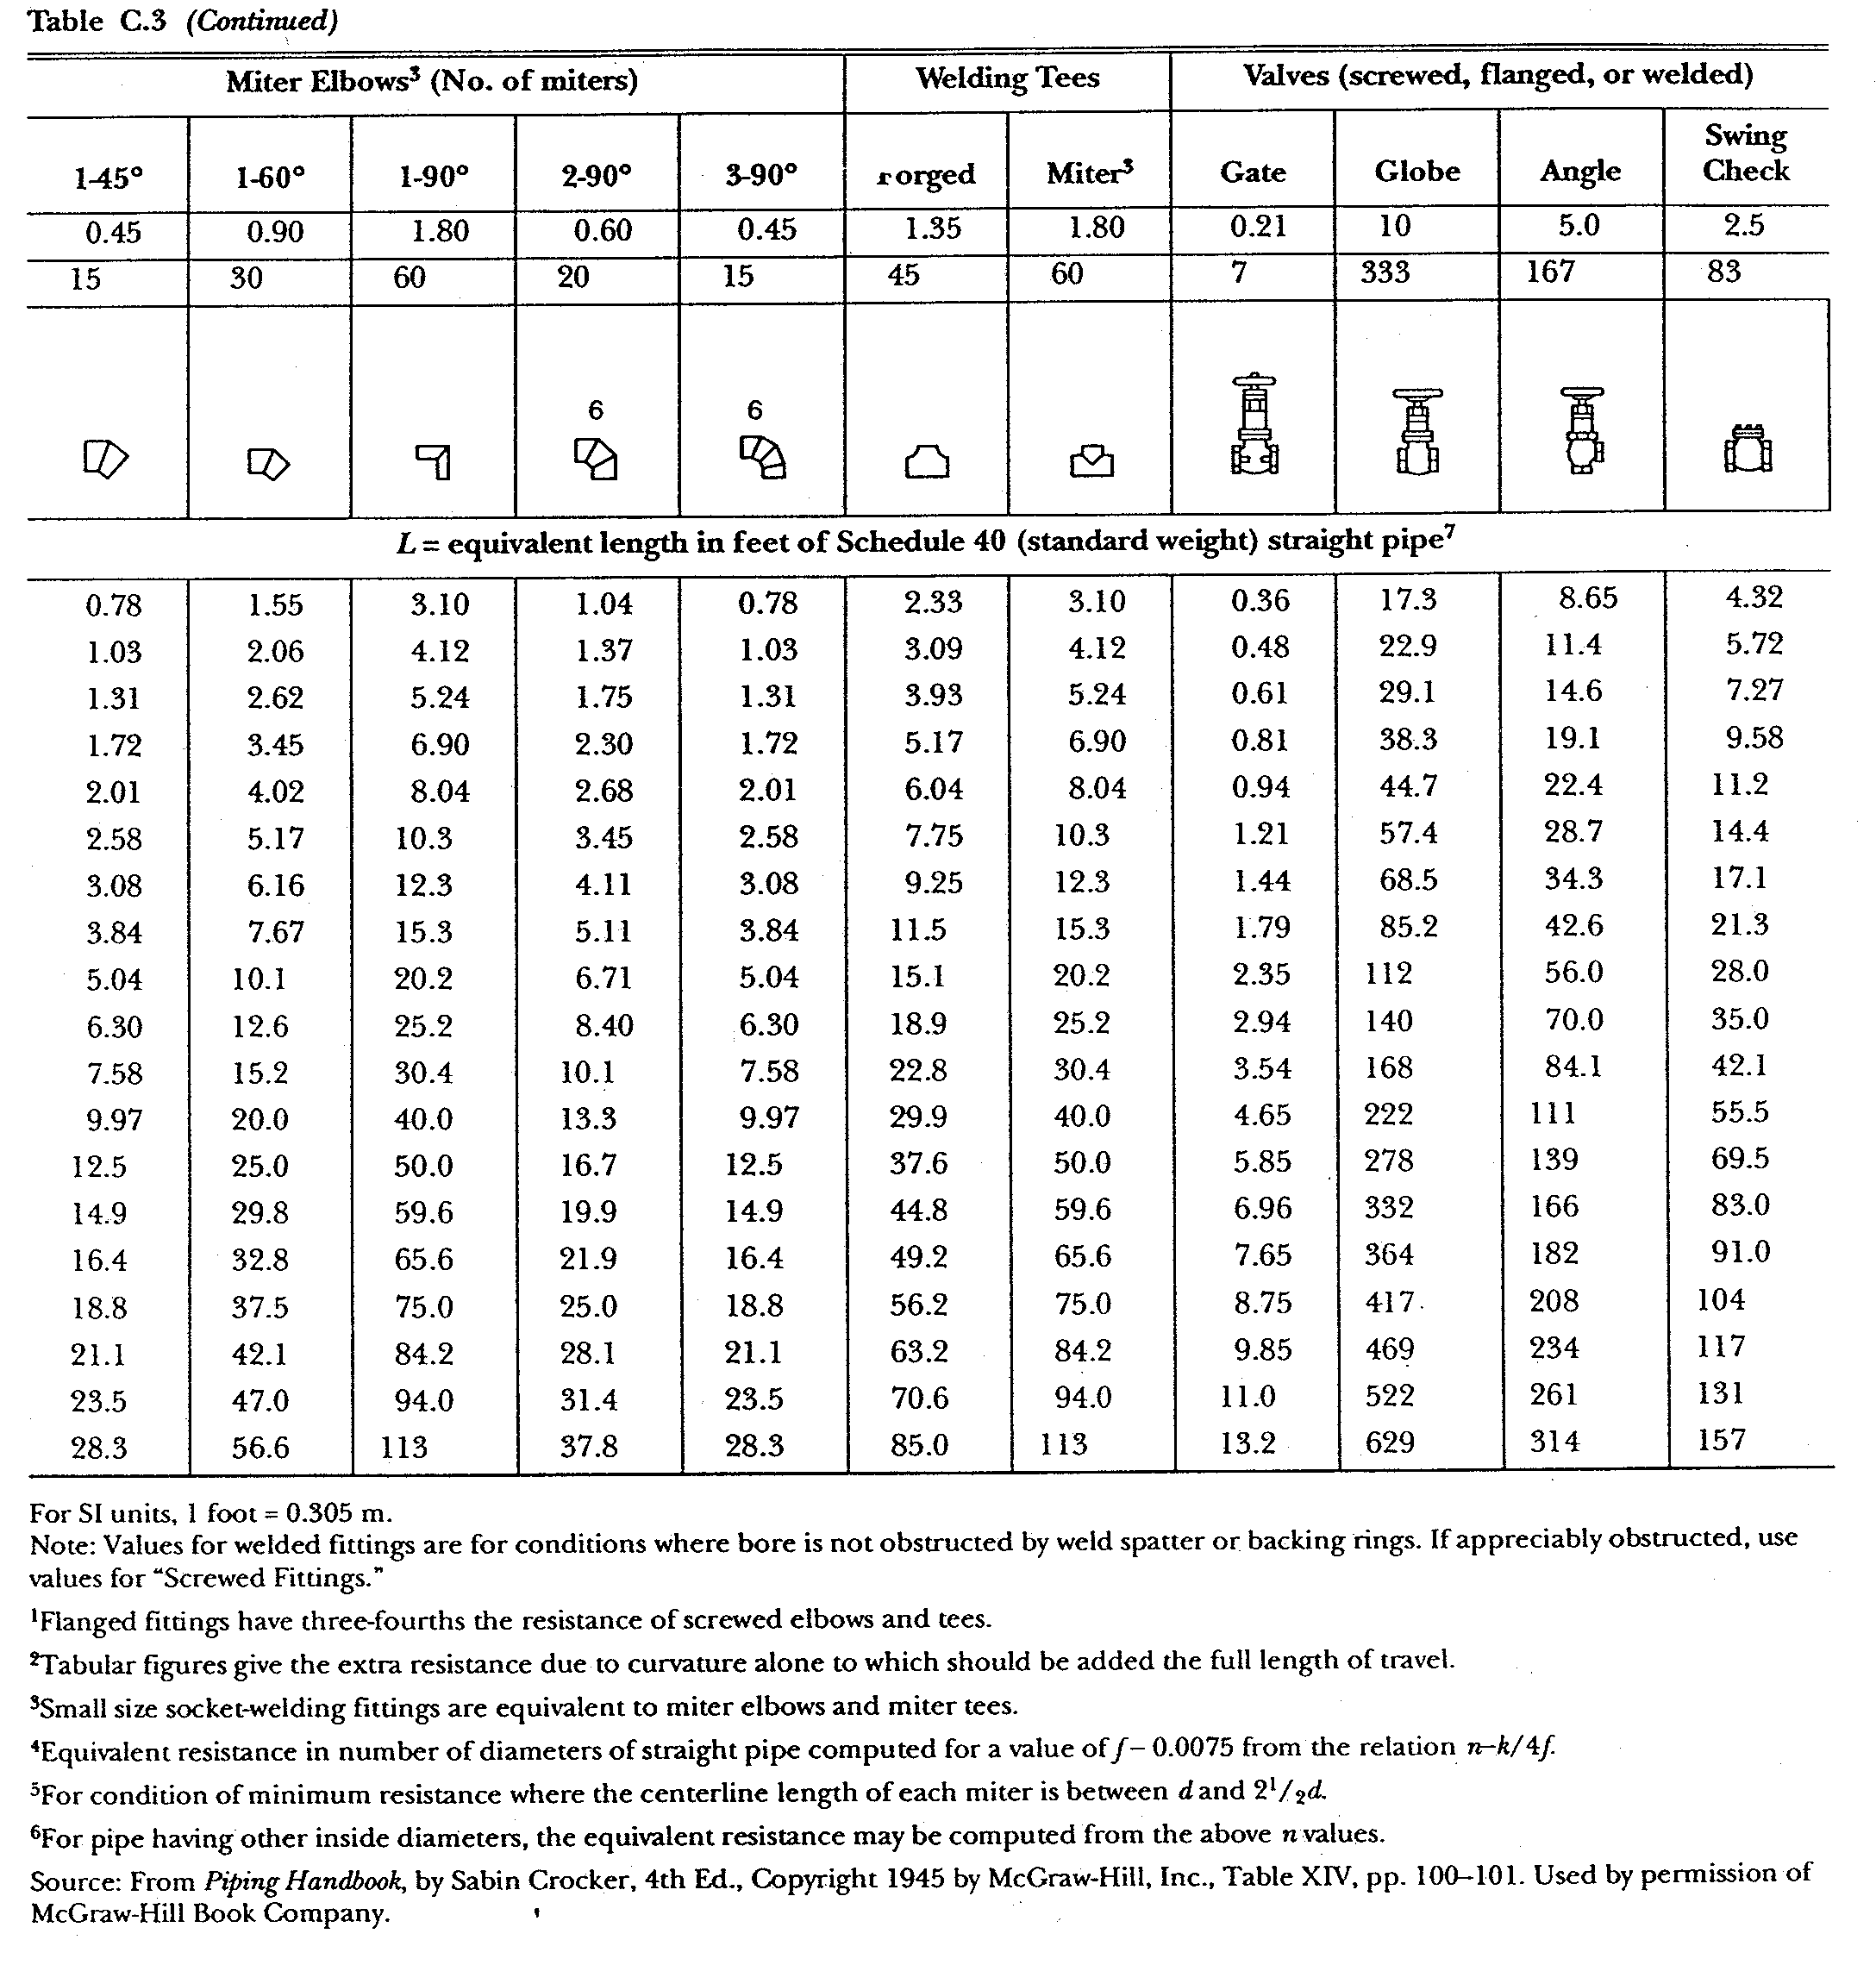
- All gas mains (piping serving more than one device) must be sized based on the total length from the meter or regulator to the most remote gas-using device.
- All gas branch lines (piping serving only one device) must be sized based on total length from the meter or regulator to the end of the branch line.
- Piping shall not be smaller than the inlet connection size at the appliance.
- In order to size the natural gas pipe, the following information is required:
- Initial gas pressure.
- Allowable pressure drop.
- Connected gas load for each device in CFH (BTUH divided by 1000).
- Length of all piping and approximate number of fittings.
- Draw a sketch of the piping system for sizing use and to put into the design file for future reference.
- Use tables in NFPA 54 for sizing the low and high pressure gas piping. These tables give CFH capacity for different pipe sizes and lengths of pipe.
- Table 9.1 is used for low pressure gas piping sizing. This table includes an allowance for an average amount of fittings in the lengths of pipe. Table 9.5 is also for low pressure gas piping sizing and does not include any fitting allowance.
- Tables 9.7, 9.8, 9.9, 9.10, 9.11, and 9.12 are used to size gas piping with 1 PSIG, 2 PSIG, 5 PSIG, and 10 PSIG initial pressure, respectively.

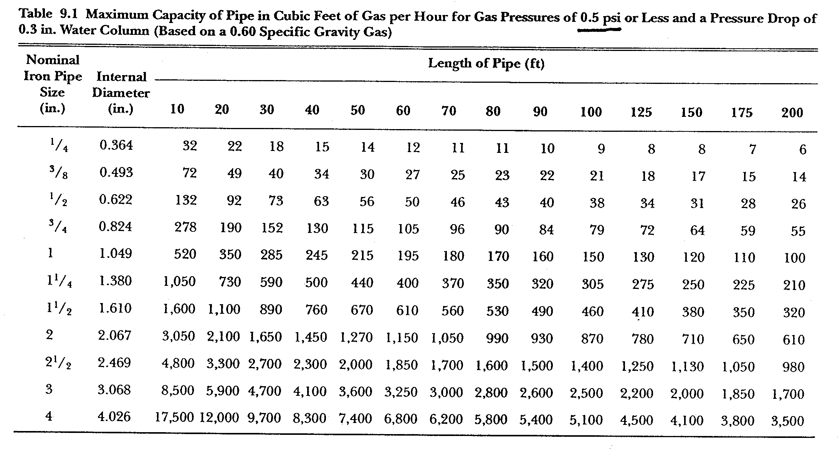

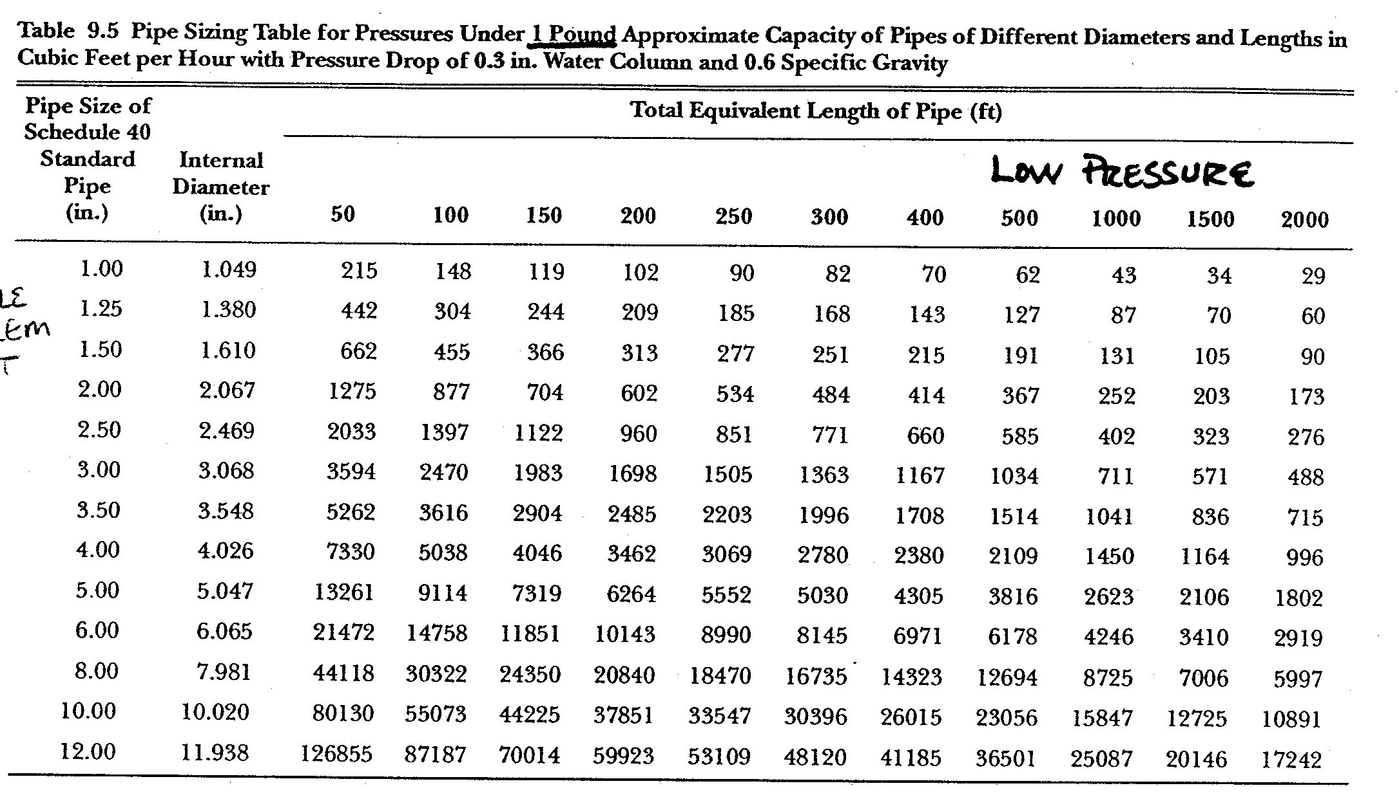
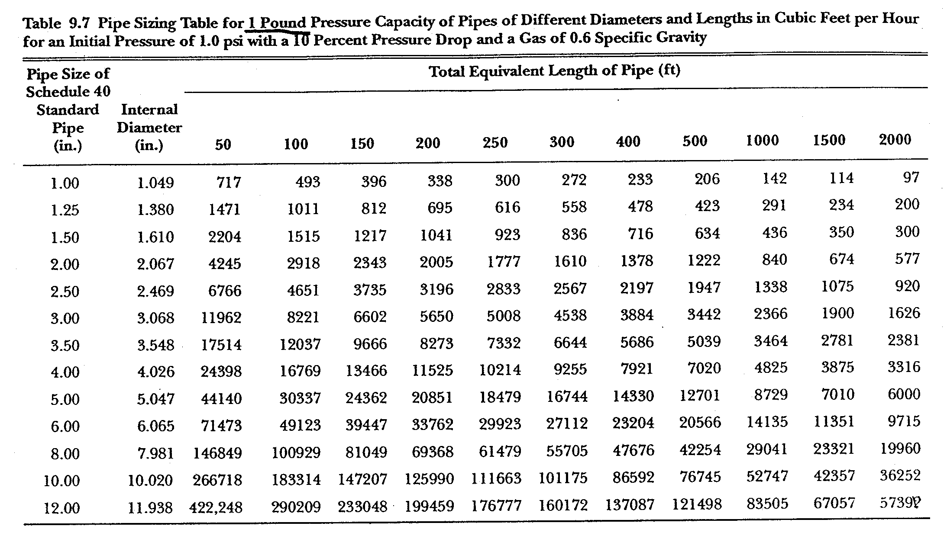

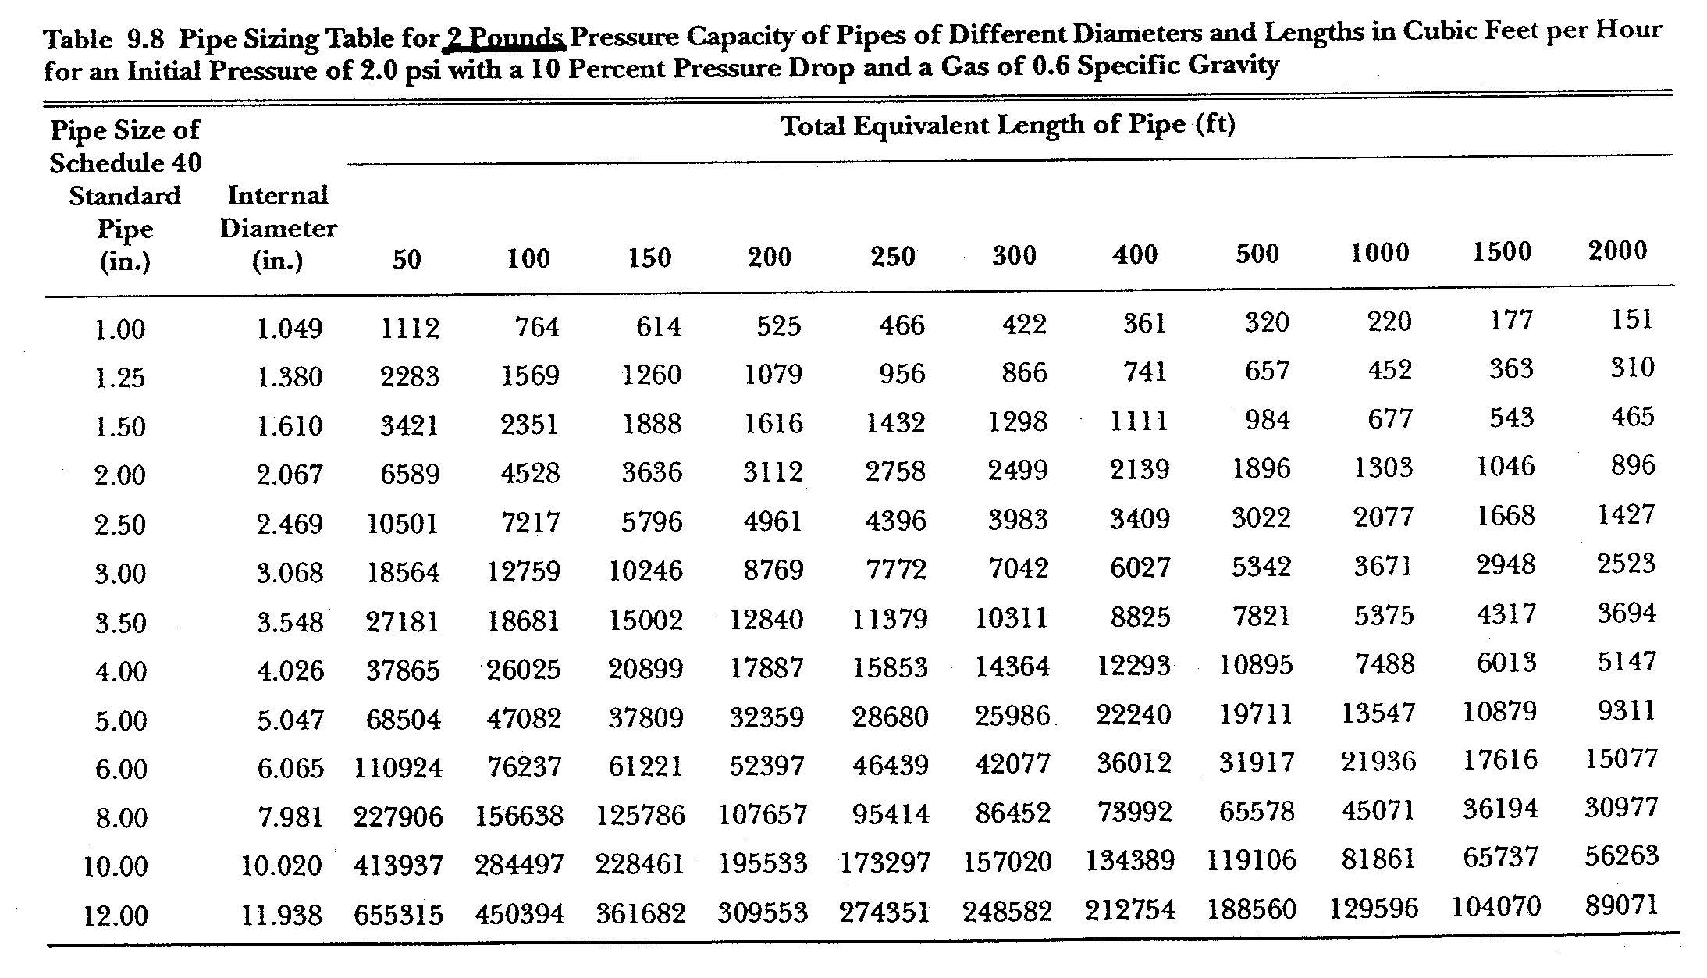

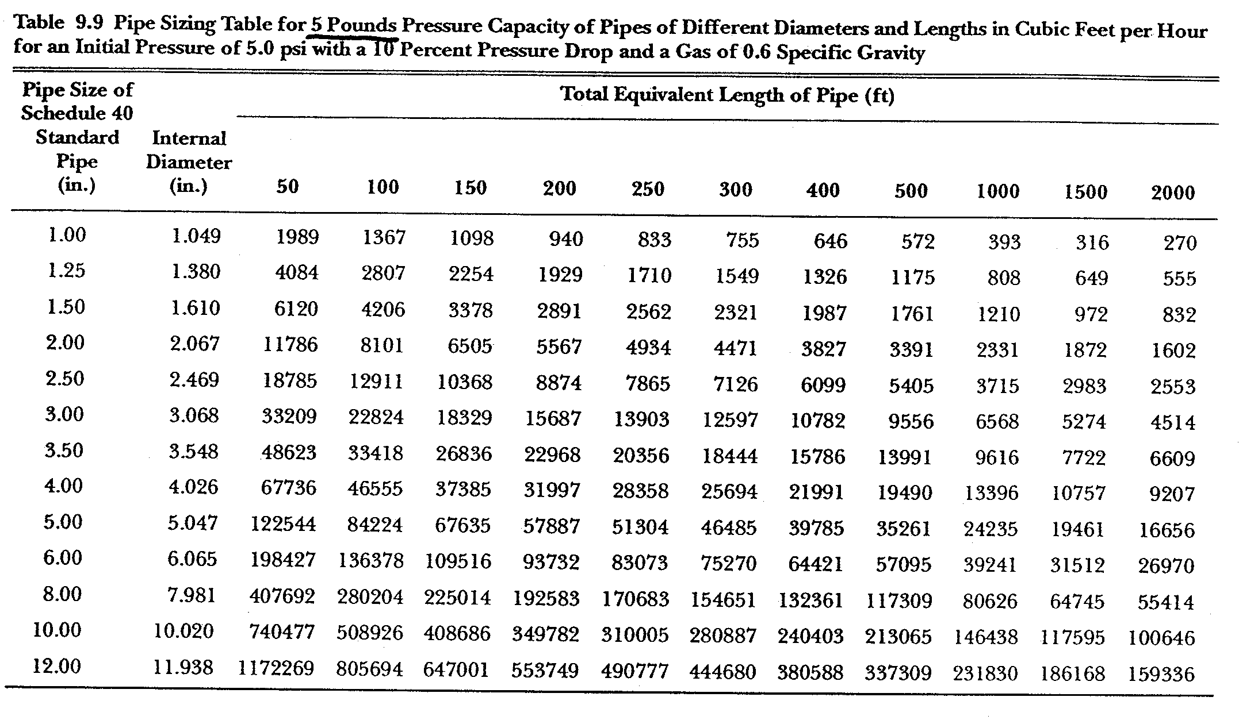

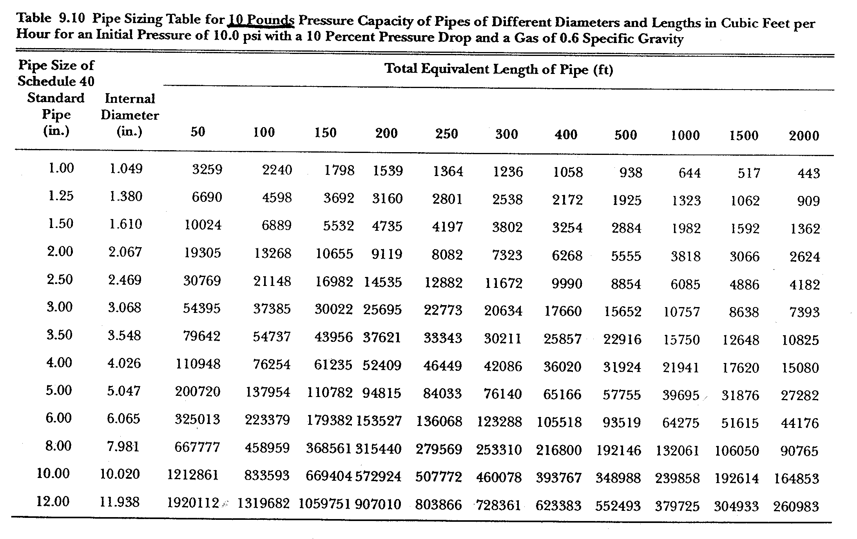

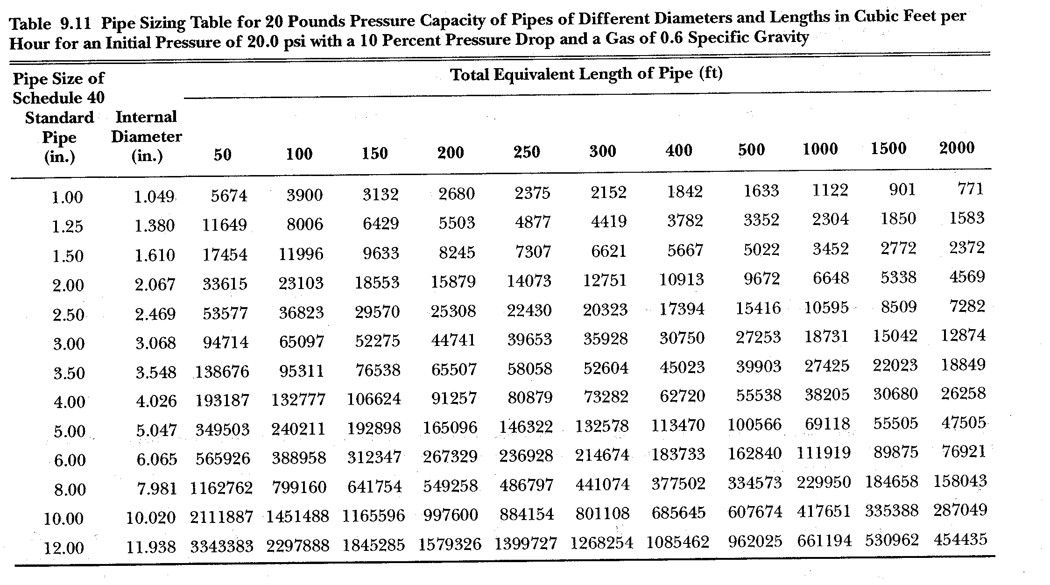

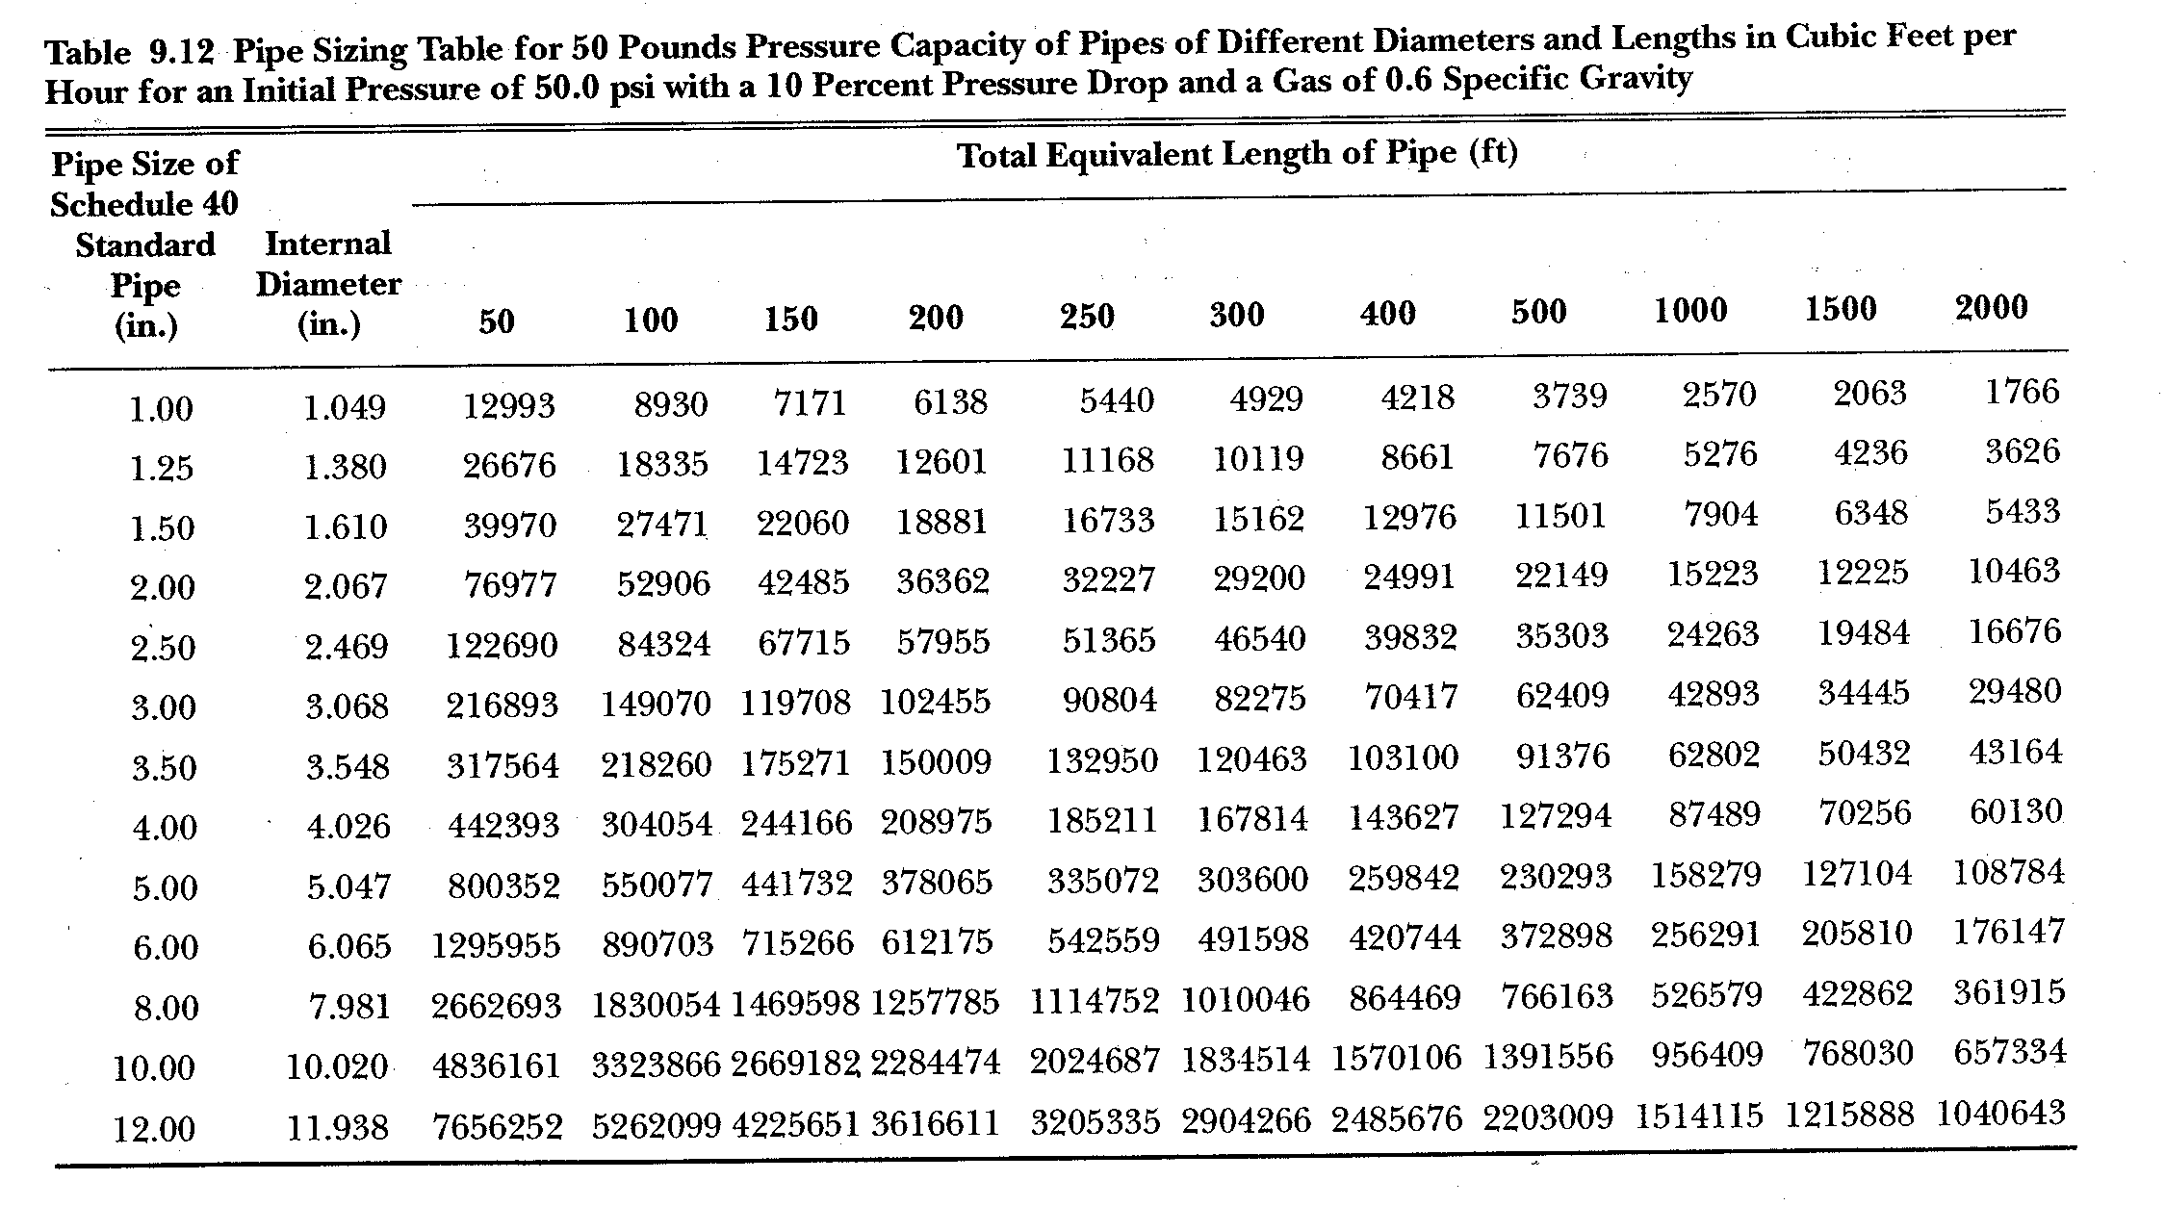

Table 9.13 Multipliers to be used with Pipe Sizing Tables when the Specific Gravity of the Gas is other than 0.60
Specific Gravity | Multiplier | Specific Gravity | Multiplier | Specific Gravity | Multiplier
0.35 | 1.31 | 0.75 | 0.90 | 1.40 | 0.66
0.40 | 1.23 | 0.80 | 0.87 | 1.50 | 0.63
0.45 | 1.16 | 0.85 | 0.84 | 1.60 | 0.61
0.50 | 1.1 | 0.90 | 0.82 | 1.70 | 0.59
0.55 | 1.04 | 1.00 | 0.78 | 1.80 | 0.58
0.60 | 1.00 | 1.10 | 0.74 | 1.90 | 0.56
0.65 | 0.96 | 1.20 | 0.71 | 2.00 | 0.55
0.70 | 0.93 | 1.30 | 0.68 | 2.10 | 0.54

Natural Gas Pipe Sizing example (reference sizing drawings):
- Drawing 1 shows a typical gas piping system schematic that should be included inside your project design notebook. Drawing 2 illustrates what a finished gas piping system might look like. These are typically hand sketched.
- To size the main (Main A) downstream of the meter:
- Total flow = 1210 CFH (this pipe will carry the entire gas load). Total length = 200’ (this pipe is a main and the maximum pipe length must be used, meter to unit heater). Using Table 9.1, a 3” pipe will carry 1700 CFH at 200’.
- To size (Main B):
- Total flow = 160 CFH (two unit heaters). Total length = 200’ (from meter to furthest unit heater). Using Table 9.1, a 1 ¼” pipe will carry 210 CFH at 200’.
- To size (Main C):
- Total flow = 1050 CFH (boiler and water heater). Total length = 100’ (from meter to the water heater, furthest end of this branch main). Using Table 9.1, a 2 ½” pipe will carry 1400 CFH at 100’.
- To size (Branch 1):
- Total flow = 60 CFH. Total length = 200’ (meter to end of the branch unit heater). Using table 9.1, a 1” pipe will carry 100 CFH at 200’.
- To size (Branch 2):
- Total flow = 100 CFH. Total length = 170’ (meter to end of branch unit heater). Using Table 9.1, a 1” pipe will carry 110 CFH at 175’.
- To size (Branch 3):
- Total flow = 50 CFH. Total length = 100’ (meter to end of branch water heater). Using Table 9.1, a ¾” pipe will carry 79 CFH at 100’.
- To size (Branch 4):
- Total flow = 1000 CFH. Total length = 80’ (meter to end of branch boiler). Using Table 9.1, a 2 ½” pipe will carry 1600 CFH at 80’.
PROBLEM: Drawing 3.

PROPANE FUEL GAS SYSTEMS

The following is some terminology and data for forms of fuel gas we typically encounter:

- Natural Gas - A mixture of gases, mostly hydrocarbons, predominantly methane. Specific gravity (SG) is typically 0.55 to 0.65 and heating value (HV) is approximately 1,000 Btu/cf. Tables are based on NFPA 54, which lists the assumptions for gas specific gravity.
- LPG - Liquefied petroleum gas, a mixture of propane and/or butane. LP is liquid propane when it is held in a storage tank until turned into gas/vapor form.
- Propane - A gaseous hydrocarbon of the methane series (C₃H₈). Has a HV=2,500 Btu/cf and an SG=1.53. Most tables will not list the specific gravity assumed.

A tank generally holds the liquid propane. An air-gas mixer adds air into the liquid at the tank to form a gas blend similar to natural gas. However, natural gas and propane equipment are not directly interchangeable because the differing specific gravities require different burner orifices and heating valves. We generally write a performance specification for all devices in the system for the supplier to meet based on load and pressure, and we connect to the service that is brought to the building.

Propane piping is sized similar to natural gas by using NFPA 54 charts based on maximum main length and gas load dependent on the gas pressure.

- The storage supply outlet is generally held at 11” w.g., and piping must be designed so there is not more than 2” w.g. pressure drop to any outlet in the system.
- Tables 54-9.25,26 and 58-12.1-3 list pipe sizing between high-low regulators and low-pressure regulators-appliances for black steel piping. Assumed pressure drop is listed in the tables. Comparing natural gas and propane sizing, propane piping can generally handle twice as much load since the HV is 2.5 times per volume of gas.

When propane is the fuel source for the building, the following questions should be raised:

- Verify if Owner-provided equipment.
- What are options for tanks?
  - Above or below ground?
  - Lease or buy tank(s)?
  - Aesthetics may dictate a below ground tank, but leasing and/or cost may drive an above ground tank. The cost of digging, etc. and cost to replace may generally favor above ground.
- Who are the suppliers in the area?
  - Are there many or only a couple?
  - If there are many, leasing may be the best option. If there are only a couple suppliers, your cost may go up because of bidding and limited propane services to the area.

Propane Tank Sizing up to 1,000 Gallons

A number of assumptions were made in calculating the BTU figures listed in the table below:

    - The tank is one-half full.
    - Relative humidity is 70%.
    - The tank is under intermittent loading.

Although none of these conditions may apply, the table can still serve as a good rule of thumb in estimating what a particular tank size will provide under various temperatures. Continuous loading is not a very common occurrence on domestic installations, but under continuous loading, the withdrawal rates in the table should be multiplied by 0.25.

TANK SIZE (Gallons) | MAX. INTERMITTENT WITHDRAWAL RATE (BTU/HR) WITHOUT TANK FROSTING* IF LOWEST OUTDOOR TEMPERATURE (AVERAGE FOR 24 HOURS) REACHES…
 | 40°F | 30°F | 20°F | 10°F | 0°F | -10°F | -20°F | -30°F
150 | 214,900 | 187,900 | 161,800 | 148,000 | 134,700 | 132,400 | 108,800 | 107,100
250 | 288,100 | 251,800 | 216,800 | 198,400 | 180,600 | 177,400 | 145,800 | 143,500
500 | 478,800 | 418,600 | 360,400 | 329,700 | 300,100 | 294,800 | 242,300 | 238,600
1,000 | 852,800 | 745,600 | 641,900 | 587,200 | 534,500 | 525,400 | 431,600 | 425,000
*Tank frosting acts as an insulator, reducing the vaporization rate.

Propane Systems that Vaporize Without Using a Vaporizer

Notes:

  - Use -30°F column and specify the number of tanks that are required.
  - If multiple tanks are required, there is a minimum 3’ spacing between each per NFPA.
  - The tanks have 10 psig and 2 psig regulators. They must be supplied either at the tanks downstream of the 10 psig regulator or they can be located at the exterior of the building. NFPA 54 limits indoor pressure to 5 psig.

